SARDAR VALLABHBHAI NATIONAL INSTITUTE OF TECHNOLOGY, SURAT
DEPARTMENT OF CIVIL ENGINEERING
STRUCTURAL ENGINEERING SECTION
STRUCUTRAL ANALYSIS LABORATORY
Structural Analysis laboratory was established in the year . The laboratory is located behind the Department of Civil Engineering, Wing-B. The laboratory facilities are utilized by undergraduate students for their curriculum laboratory work. The research scholars also utilize it for the research and development activities. This lab helps to understand the behaviour of structural elements and systems under different loads. As analysis is the primary step for design therefore, this lab gives a field experienced to students. In this lab students, determine deflection of various structural elements like simply supported beam, cantilever beam, continuous beam, overhanging beam, truss, portal frame, two hinge arch, three hinge arch and curved members under various loading and supporting conditions. The laboratory has good potential to carry out research and generate revenue using calibration and testing work in future. List of equipment available in the laboratory is given below:
Sr. No. | Equipment Name
1 | Deflection of Three hinged arch apparatus
2 | Deflection of Curved members apparatus
3 | Deflection of Two hinges arch apparatus
4 | Deflection of Truss apparatus
5 | Deflection of Portal frame apparatus
6 | Deflection of Simply supported beam apparatus
7 | Deflection of Cantilever beam apparatus
8 | Deflection of Continuous beam apparatus
9 | Deflection of One sided over hanging beam apparatus
10 | Deflection of Simply supported frame apparatus
11 | Deflection of Two side over hanging beam apparatus
LIST OF EXPERIMENTS
Structural Analysis Lab (CE206) (B. Tech-II (Civil), Semester IV)
Sr. No. | Title of Experiment
1 | Deflection of Cantilever Beam
2 | Deflection of Simply Support Beam
3 | Deflection of Overhanging Beam
4 | Shear Centre for Unsymmetrical Sections
5 | Study of different models for Two and Three dimensional structures
6 | Force Determination and deflection study of 2D and 3D truss
7 | Verification of energy based deflection method for indeterminate truss
8 | Verification of energy based deflection method for indeterminate beam
9 | Boundary conditions effects on determinate and indeterminate structures

Photos of Some Experimental Set Ups

DEFLECTION OF THREE HINGED ARCH APPARATUS 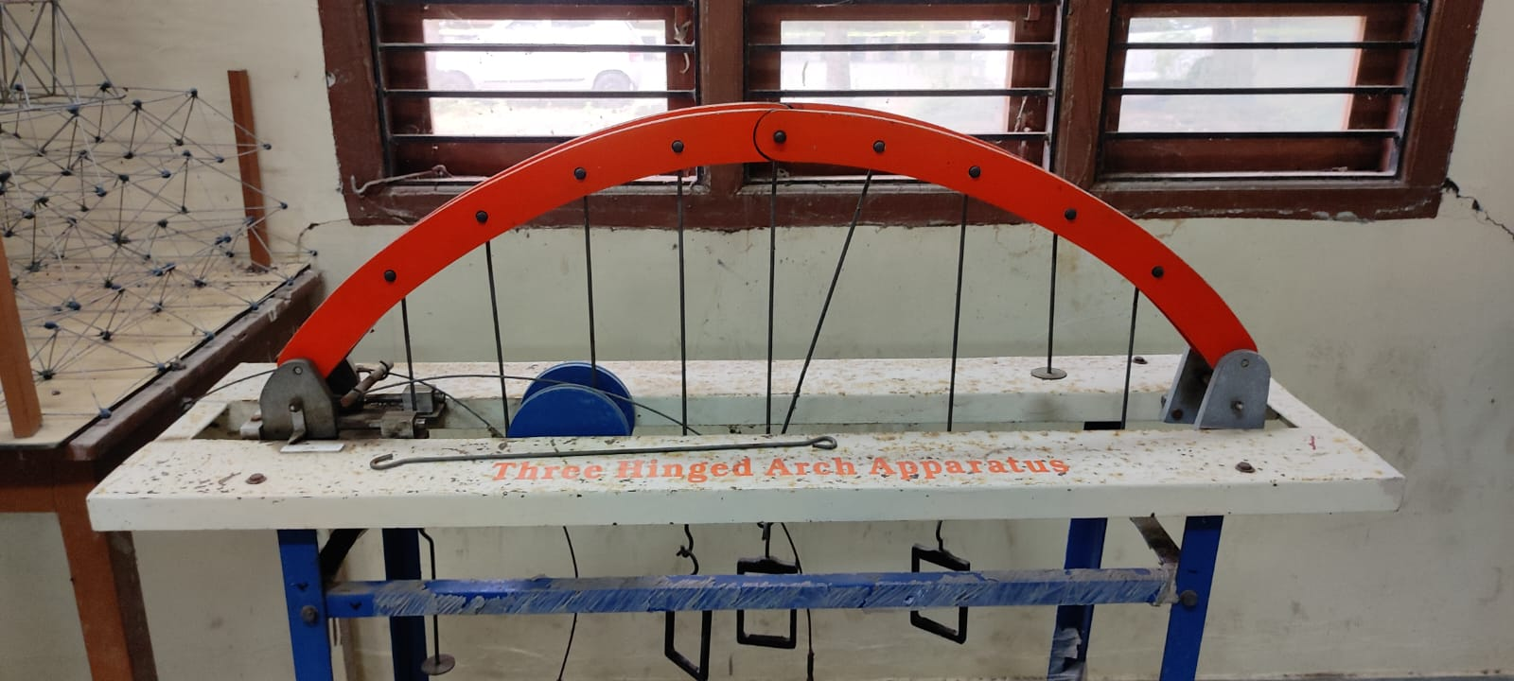

DEFLECTION OF CURVED MEMBERS APPARATUS

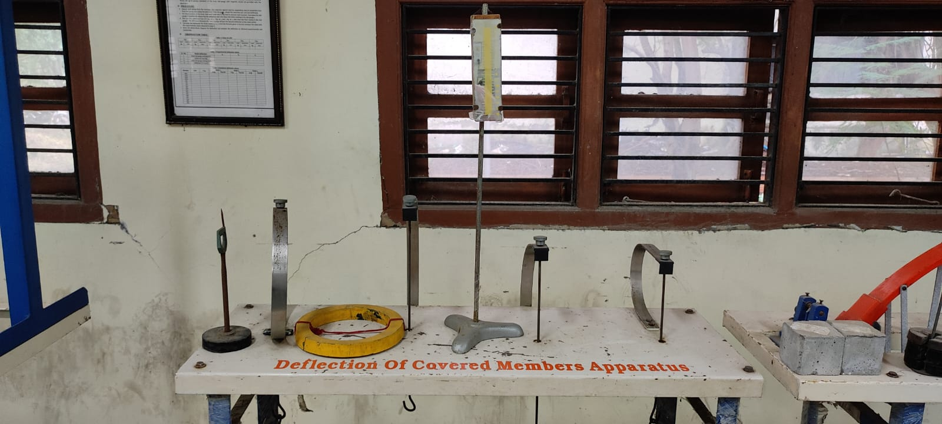

DEFLECTION OF TWO HINGES ARCH APPARATUS

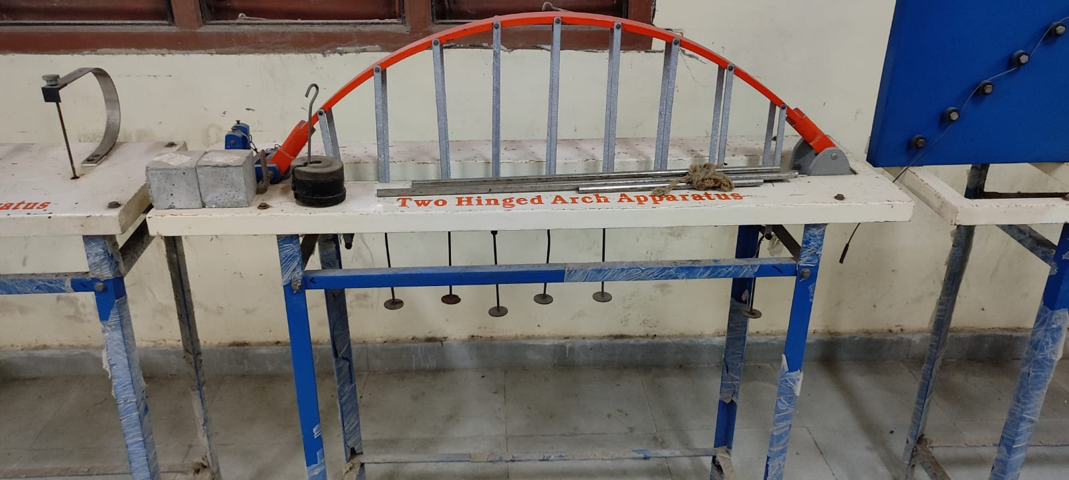

DEFLECTION OF DEFLECTION OF TRUSS APPARATUS

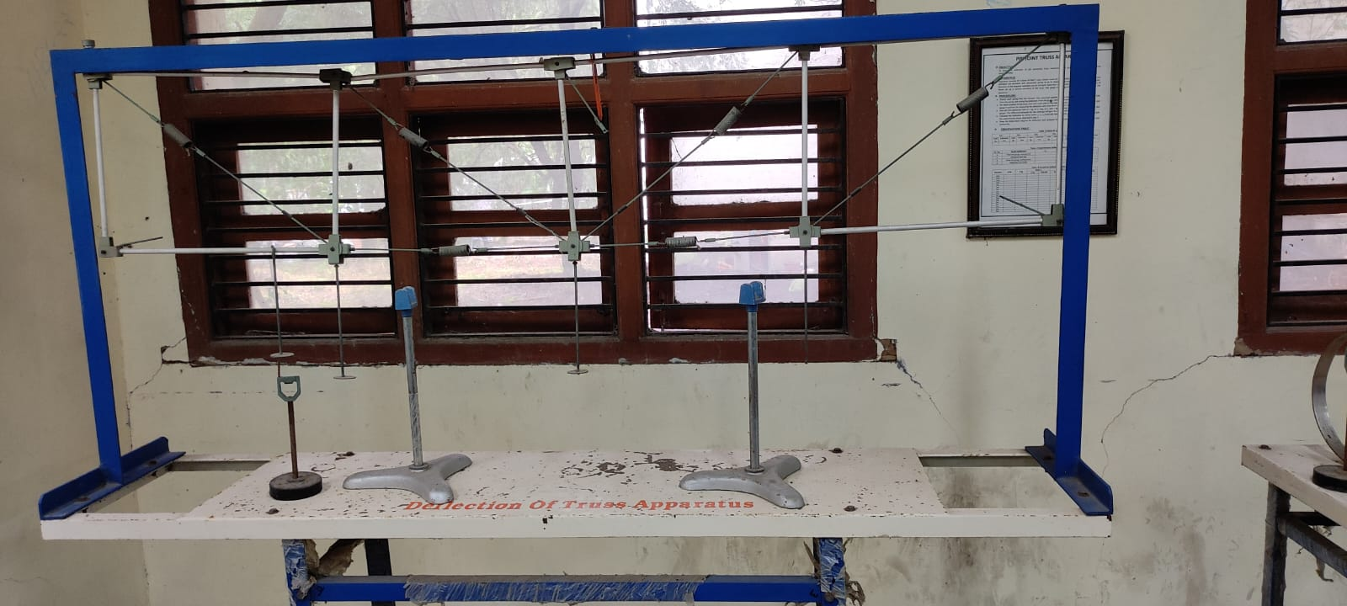

DEFLECTION OF PORTAL FRAME APPARATUS

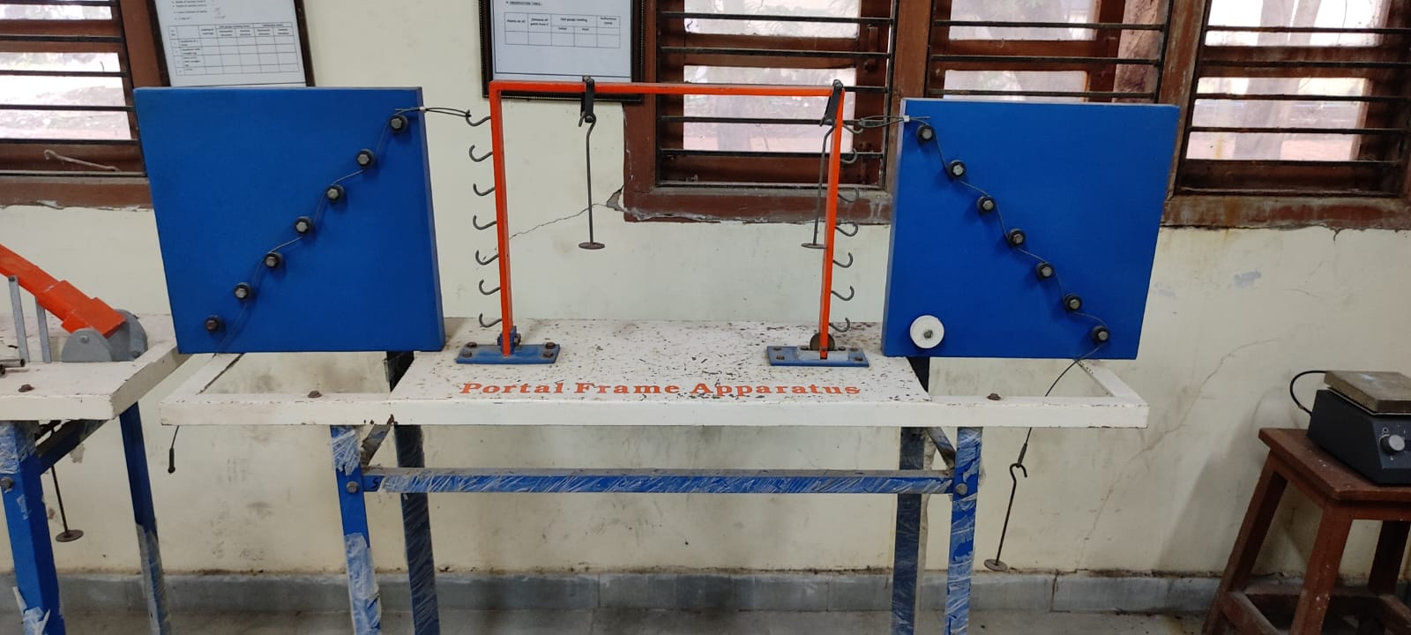

DEFLECTION OF SIMPLY SUPPORTED BEAM APPARATUS

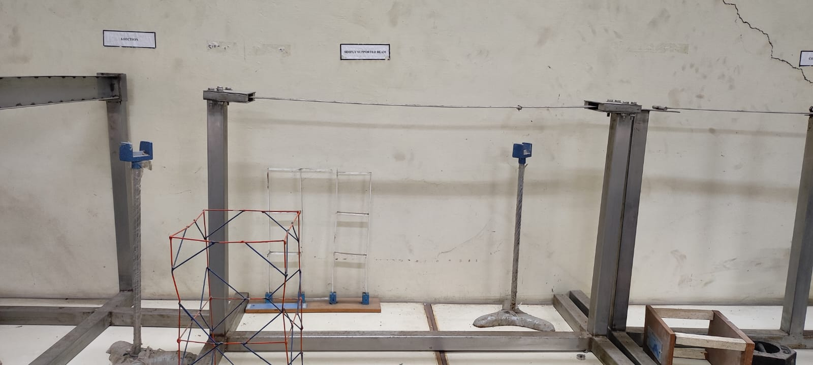

DEFLECTION OF CANTILEVER BEAM APPARATUS

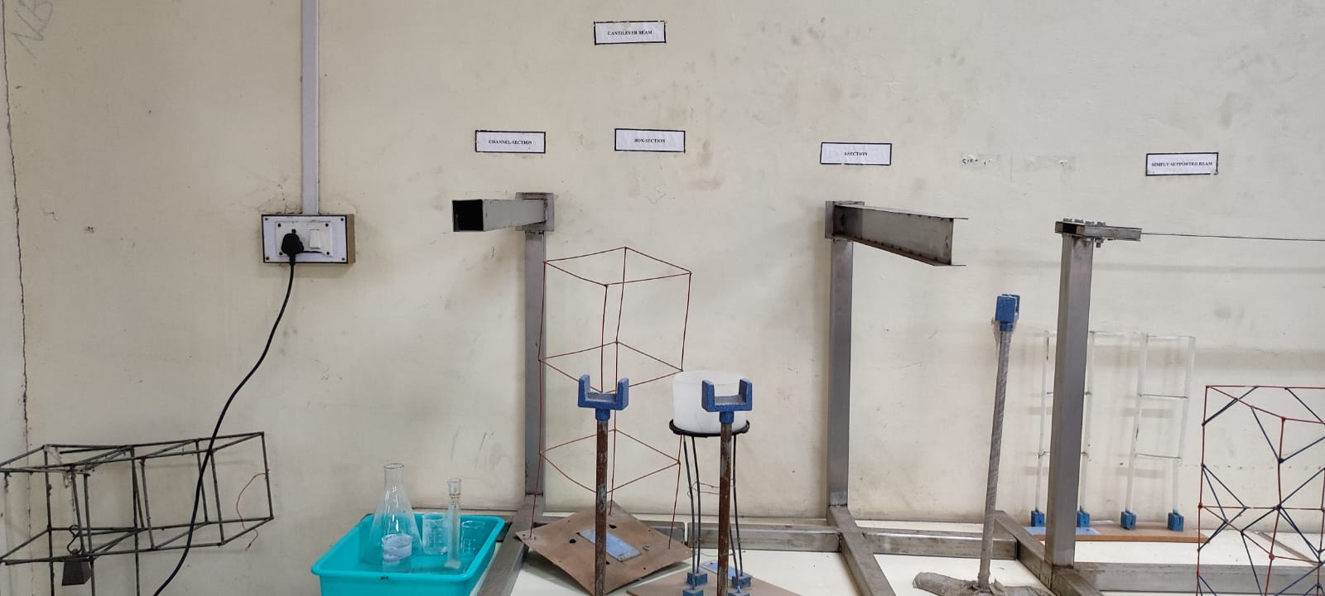

DEFLECTION OF CONTINUOUS BEAM APPARATUS

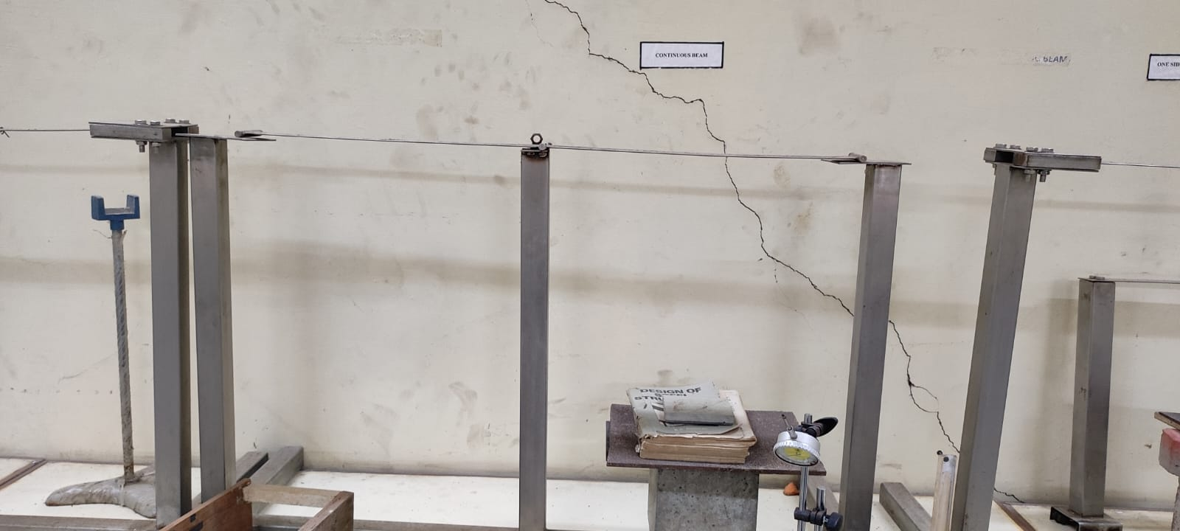

DEFLECTION OF ONE SIDED OVER HANGING BEAM APPARATUS

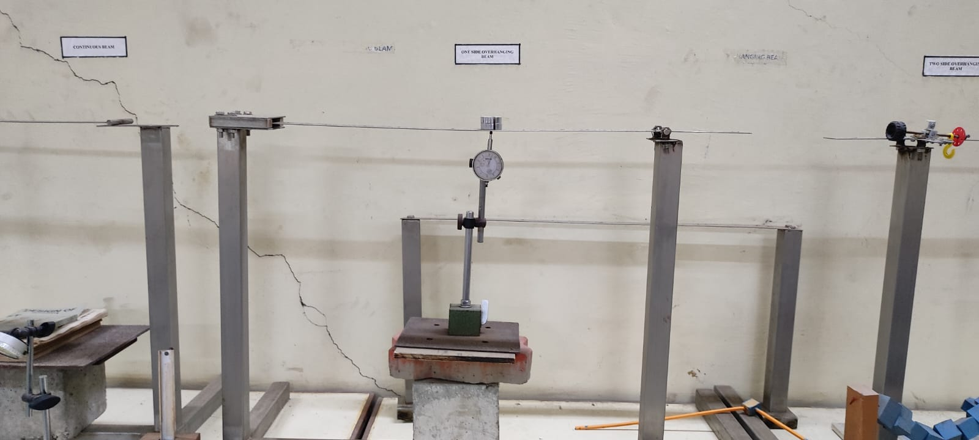

DEFLECTION OF SIMPLY SUPPORTED FRAME APPARATUS

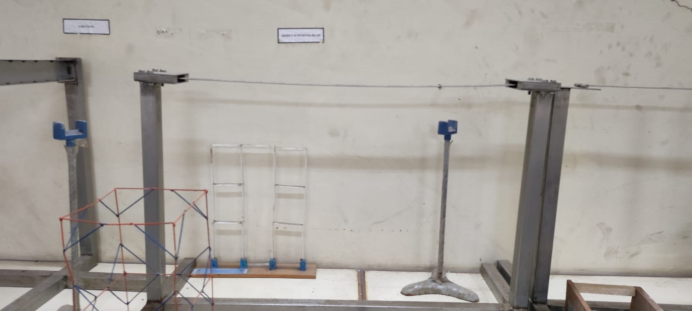

DEFLECTION OF TWO SIDE OVER HANGING BEAM APPARATUS

